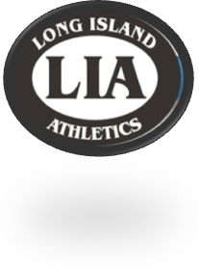
Long Island Athletic Supply
34 Hempstead Turnpike
Farmingdale, NY 1735
P: 516-293-8712 F: 516-293-8546
Email: sales@longislandathletic.com

Holy Family Track
Apparel Spring 2022

This year’s Holy Family Track Apparel will be offered via our online order form. To place your order, log onto our website: www.liathletic.com

- In the text box below “Have a Team Code? Enter it Here”, type the Team Code Provided Below.
- Your TEAM CODE: HOLYFAMTRACKSPRING22
- Once orders are complete, Local Orders will be distributed at a practice or meet.
- If you do not receive an e-mail confirmation, please check your SPAM or JUNK Folder.

The ordering period will only be open from Friday, March 18th, 2022 through Friday, April 8th, 2022. You will not be able to order after this date. All orders are processed after the ordering period ends.

All sample sizes are available to try on at Long Island Athletics in our Farmingdale location. It is STRONGLY recommended that you take the time to see sizing samples. All orders are custom and therefore final with no refunds or exchanges.

If you have any questions, please do not hesitate to call us at
516-293-8712.

