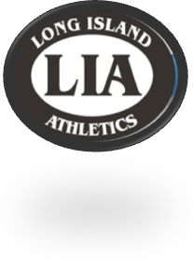
Long Island Athletic Supply
34 Hempstead Turnpike
Farmingdale, NY 1735
P: 516-293-8712 F: 516-293-8546
Email: sales@longislandathletic.com

Holy Family Volleyball
Winter 2019

This year’s Holy Family Volleyball Apparel will be offered via our new online order form. To place your order, log onto our website: www.liathletic.com

- In the text box below “Have a Team Code? Enter it Here”, type the Team Code Provided Below.
- Your TEAM CODE: HOLYFAMVBALLWINTER19
- We currently DO NOT offer shipping. Once orders are complete, they will be distributed at a practice.
- If you do not receive a confirmation e-mail, please check your SPAM or JUNK Folders

The ordering period will only be open from Friday, February 1st, 2019 through Friday, February 15th, 2019. You will not be able to order after this date. All orders are processed after the ordering period ends.

All sample sizes are available to try on at Long Island Athletics in our Farmingdale location. It is STRONGLY recommended that you take the time to see sizing samples. All orders are custom and therefore final with no refunds or exchanges.

If you have any questions, please do not hesitate to call us at
516-293-8712.

