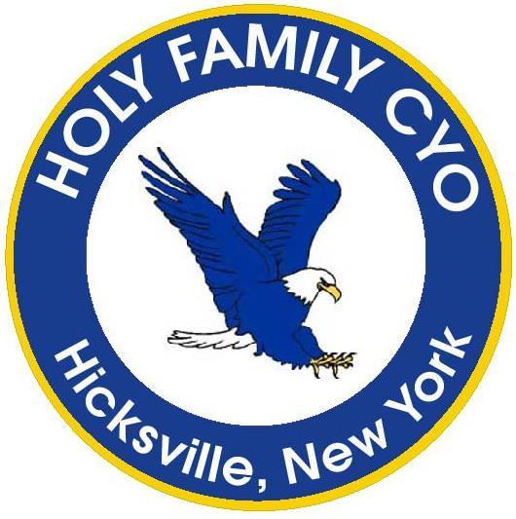
www.holyfamilycyo.org
Online Registration
Now Open!

SUMMER
2022
INSTRUCTIONAL
BASKETBALL
CLINIC

BOYS and GIRLS
Grades Kindergarten to 4th
Price: $125.00

Our summer instructional clinic introduces our K through 4th grade children (Boys & Girls) to the game of basketball. 5 Sessions are held on Tuesdays 6-730pm. Girls and Boys play together. See schedule below.

The clinic starts in June, BUT THE TIME TO SIGN UP IS NOW!

Register by visiting our website www.holyfamilycyo.org.
Click on the “Basketball” or “Registration” tab on the left.
Registration closes June 9th!!!

All participants receive a Holy Family Basketball Pinny!

Questions may be sent to holyfamilycyo@gmail.com

SCHEDULE: Tuesdays, 6-730pm: June 28, July 5, 12, 19, 26

