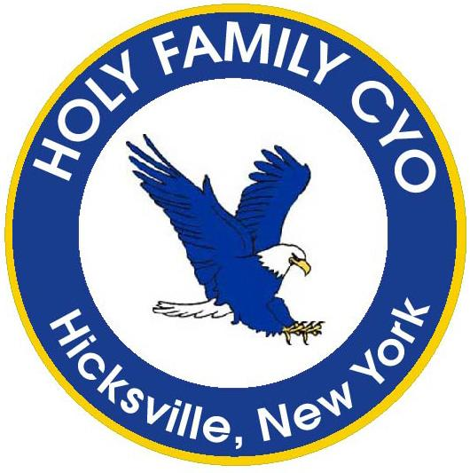
www.holyfamilycyo.org
Online Registration
Now Open!

2022
GIRLS
INSTRUCTIONAL
VOLLEYBALL

Grades – 3rd, 4th & 5th
Price: $125.00
Our instructional program introduces our 3rd, 4th and 5th grade girls to the game of volleyball. Instructional volleyball is a great way to prepare for our competitive travel team which has produced numerous championships!

The program starts in May BUT THE TIME TO SIGN UP IS NOW!

Register by visiting our website www.holyfamilycyo.org
Questions? holyfamilycyo@gmail.com

Five (5) double sessions on Saturdays 10-12 PM
May 7, 14, 21, 28,
June 4

Parents interested in volunteering should contact holyfamilycyo@gmail.com and indicate when registering your child

