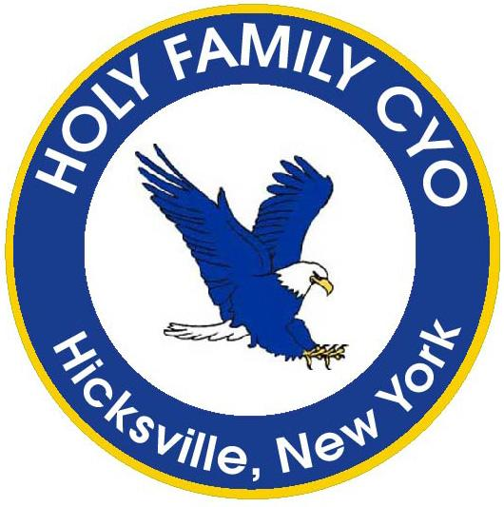
www.holyfamilycyo.org
Online Registration
Now Open!

2022
GIRLS TRAVEL
VOLLEYBALL

Grades – 5th, 6th, 7th, 8th, Tyro and Seniors
Price: $175.00

Travel Volleyball
Our travel volleyball program is designed for girls in grades 5 through 12 who are looking to participate in a competitive environment. There is normally one travel team per grade. Players are selected to teams by try-outs. The Travel teams will play teams from other Catholic parishes in Nassau or Suffolk County. Travel teams play a 10 match schedule followed by playoffs for the top teams in each division. There is normally one practice and one game per week although there could be multiple games in a week. The season starts in January BUT THE TIME TO SIGN UP IS NOW! The season runs through May.

Parents interested in coaching and/or assisting should indicate so when they register their child.

Register by visiting our website www.holyfamilycyo.org. Click on the “Registration” tab on the left and follow the simple instructions.

Questions may be sent to carito12397@hotmail.com.

